Week of 7/1:
- Warm-Up
- Barbell Squat
  - 3-4 sets of 8-15 reps
- Barbell deadlift
  - 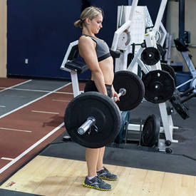4 sets of 8-15 reps
- Seated DB bent over rear Delt Raise
  - 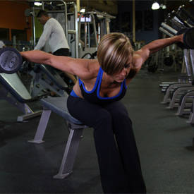3-4 sets of 8-15 reps
- Barbell Bench Press (Close Grip)
  - 3-4 sets of 15-20 reps
- DB Flyes
  - 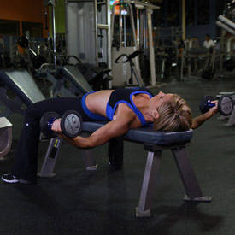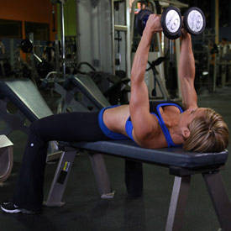3-4 sets of 8-15 reps

