Week of 6/24:

* Warm-Up
* Barbell Lunge
  + 3-4 sets of 8-15 reps
* Barbell deadlift
  + 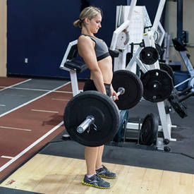4 sets of 8-15 reps
* Seated DB Press
  + 3-4 sets of 8-15 reps
* DB One-Arm Tricep Extension
  + 3-4 sets of 8-15 reps
* Push-Ups
  + 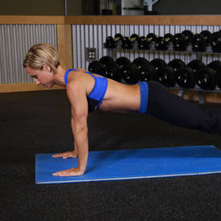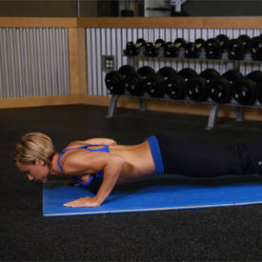3-4 sets of 12-15 reps