Week of 6/17:

* Warm-Up
* DB Squat
  + 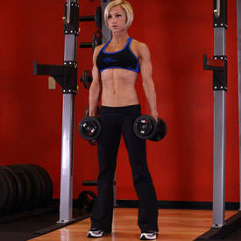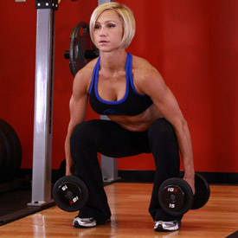3-4 sets of 8-15 reps
* Bent over Barbell Row
  + 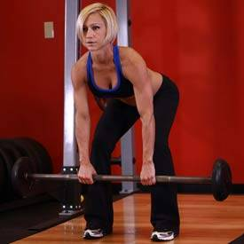4 sets of 8-15 reps
* Upright barbell row
  + 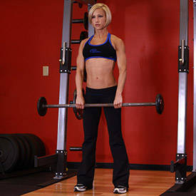3-4 sets of 8-15 reps
* Barbell Curl
  + 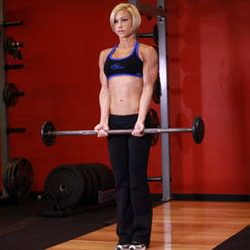3-4 sets of 8-15 reps
* Barbell Bench Press (Medium Grip)
  + 3-4 sets of 8-15 reps